ACADEMY WRESTLING CLUB SUMMER CAMPS 2019
Located at Christian Brothers Academy (Wrestling Room)
850 Newman Springs Road
Lincroft, NJ 07738

CAMP #1 Session 1: July 12th 3PM-6PM Session 2: July 13th 9AM–12PM Session 3: July 14th 9AM–12PM
CLINICIANS: Anthony Ashnault & Sebastian Rivera

CAMP #2 Session 1: July 19th 3PM-6PM Session 2: July 20th 9AM–12PM Session 3: July 21st 9AM–12PM
CLINICIANS: Ryan Deakin, Jimmy Kennedy, Sebastian Rivera, and Matt Storniolo
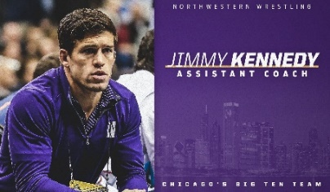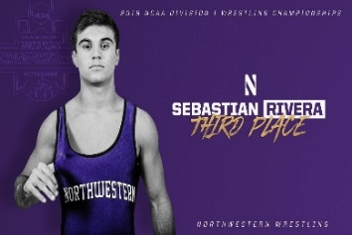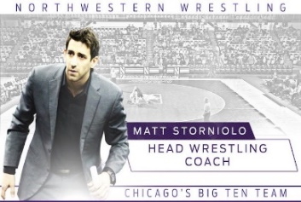

CAMP #3 Session 1: July 22nd 9AM-12PM Session 2: July 23rd 9AM–12PM Session 3: July 24th 9AM–12PM
CLINICIANS: Joe Dubuque, Pat Glory, and Sean Gray
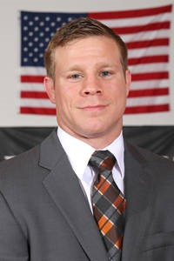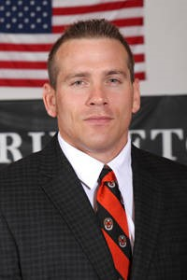

CAMP #4 July 26th 9AM-12PM
CLINICIANS: Yianni Diakomihalis & Mike Grey
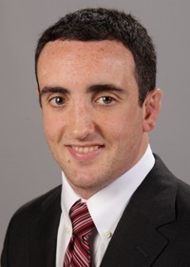

--------------------Please Fill Out and Mail The Form (With Payment) to the Address Listed Below--------------------
Camp #1 $200: Attending YES NO (Circle One)
Camp #2 $200: Attending YES NO (Circle One)
Camp #3 $200: Attending YES NO (Circle One)
Camp #4 $100: Attending YES NO (Circle One)
First Name:____________________
Last Name:___________________________
Address:_____________________________
City:__________________________ Zip: _________ PAYMENT TYPE: CHECK (Mail With Form)

Weight:_____Date of Birth:________ CASH (BRING To Camp)
Make Checks Payable To: The Academy Wrestling Club
Mail To: The Academy Wrestling Club
58 Birch Lane
Eatontown, NJ 07724
QUESTIONS? washnault@theacademywrestling.com
908-834-1299

Phone:______________Email:_______________________
Parent Signature:________________________________
I understand that physical risks are involved in my child's participation
in the The Academy Wrestling Club.I also understand that these risks
may range from minor bruises to life threatening injuries.I have made
my child aware of these risks and by allowing him/her to participate in
the Wrestling Club,hereby affirm that I fully assume responsibility for
these risks.My signature above confirms my agreement with these statements. *OPEN TO ANY AND ALL*

