CLINIC PHILOSOPHY

This clinic is designed specifically for the young wrestler who wants to improve dramatically from the top position. Leg riding, double-grapevines, crab rides, tilts, arm bars, and other pinning combinations will be stressed. The instruction will feature a system of top wrestling, rather than a “barrage of moves.” At week’s end, campers will be much more confident in their ability to ride, turn and ultimately pin their opponents.

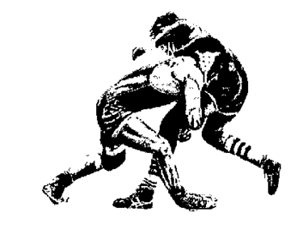

BECOME A

BEAST ON TOP!

GOLD MEDALIST WRESTLING CAMP
26 C Maple Lane
Brielle, NJ 08730
Tel: 732-864-6131
Fax: 732-739-0824
Email: caravella@sjvhs.com

TONY CARAVELLA’S
GOLD MEDALIST CAMP

LEG WRESTLING
AND
TILT CLINIC

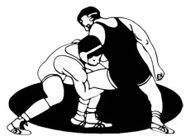

SAINT JOHN VIANNEY HS
HOLMDEL, NJ

JUNE 24-JUNE 27, 2019
6:00PM-8:00 PM

BRICK MEMORIAL/SJVHS
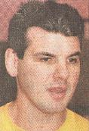
A TRADITION OF EXCELLENCE

Brick Memorial
Head Coach
(1981-2002)
317 victories
2 #1 rankings in NJ
5 Group 3 Titles
10 Sectional Titles
13 SCT Championships
14 Division Titles
4 State Titles
4 State Champions
42 State Medalists
42 Region Champions
114 District Champions
Region 6 Hall of Fame
South Jersey Wrestling Hall of Fame

Current Assistant Coach
At SJV
(Class A Central and SCT Champions 2018)

Name: _____________________________

Address: ___________________________
_____________________________

Phone#__________________________

Birthdate:__________

Grade:_________(this coming year)

Health Insurance:

(Provider)

(Policy #)

Each participant of the Gold Medal Wrestling Camp will be additionally covered by a secondary insurance provider.

Years of Wrestling Experience:

T-Shirt size (Adult only, Circle One)

S M L XL XXL

A $150 check/money order must accompany this application to ensure registration.
Please make check payable to:

Gold Medalist Wrestling Camp
26 C Maple Lane, Brielle, NJ 08730

FOR FURTHER INFO CALL: (732) 864-6131

DATE: JUNE 24 – JUNE 27, 2019
TIME: 6:00pm – 8:00pm

At SAINT JOHN VIANNEY HS
540 LINE ROAD, HOLMDEL, NJ

AGE: Grade 6-12 (2018-2019 school- year)

COST: $150.00
Please make check payable to:
Gold Medal Wrestling Camp
26 C Maple Lane
Brielle, NJ 08730
CAMP FEATURES
- One-on-one instruction
- DVD of technique instruction will be given to each participant
- Secondary insurance provided to all participants
- Guest instructors
- Top level technique instruction
(Cross body rides and pinning combinations, double grapevine, tilts, crab ride, cradles, arm bars, halfs, leg “defense”, funk wrestling)

The instruction will feature a system of top wrestling, rather than a “barrage of moves.” At week’s end, campers will be much more confident in their ability to ride, turn and ultimately pin their opponents.

